**7T semi-LASER GABA MRS**

November 2023

Outline

Documents 1

Sequences 2

Software 2

Pre-processing sLASER data 2

Preprocessing procedure 2

Fitting procedure 3

Data quality checks 3

After pre-processing 6

Tissue correction 7

Table: example values of data quality indices 9

MRS-rsfMRI-behaviour relational analyses 10

MRS main effects 10

MRS with behaviour 10

MRS with rsfMRI 11

rsfMRI with behaviour 12

Useful notes on different analyses 13

Appendix 1-Notes on MRspa 14

Appendix 2-MRspa pipeline 15

Appendix 3-Install LCmodel 35

Appendix 4-Training Data 36

# Documents

This document refers to scripts that can be found:

1. Web address: 10.49.215.183:300 (refer to Server SOP)
2. /data/fox_cloud/share/app/imaging/MRS_ACTIVE/Scripts_and_Software

Scripts for MATLAB can be found in:

/data/fox_cloud/share/app/imaging/MRS_ACTIVE/Scripts_and_Softeare/Full_analysis_pipeline_MATLAB/scripts

Please note that, each time we open Matlab, remove files contain ‘mrs’ like below from set path, in case of any error.

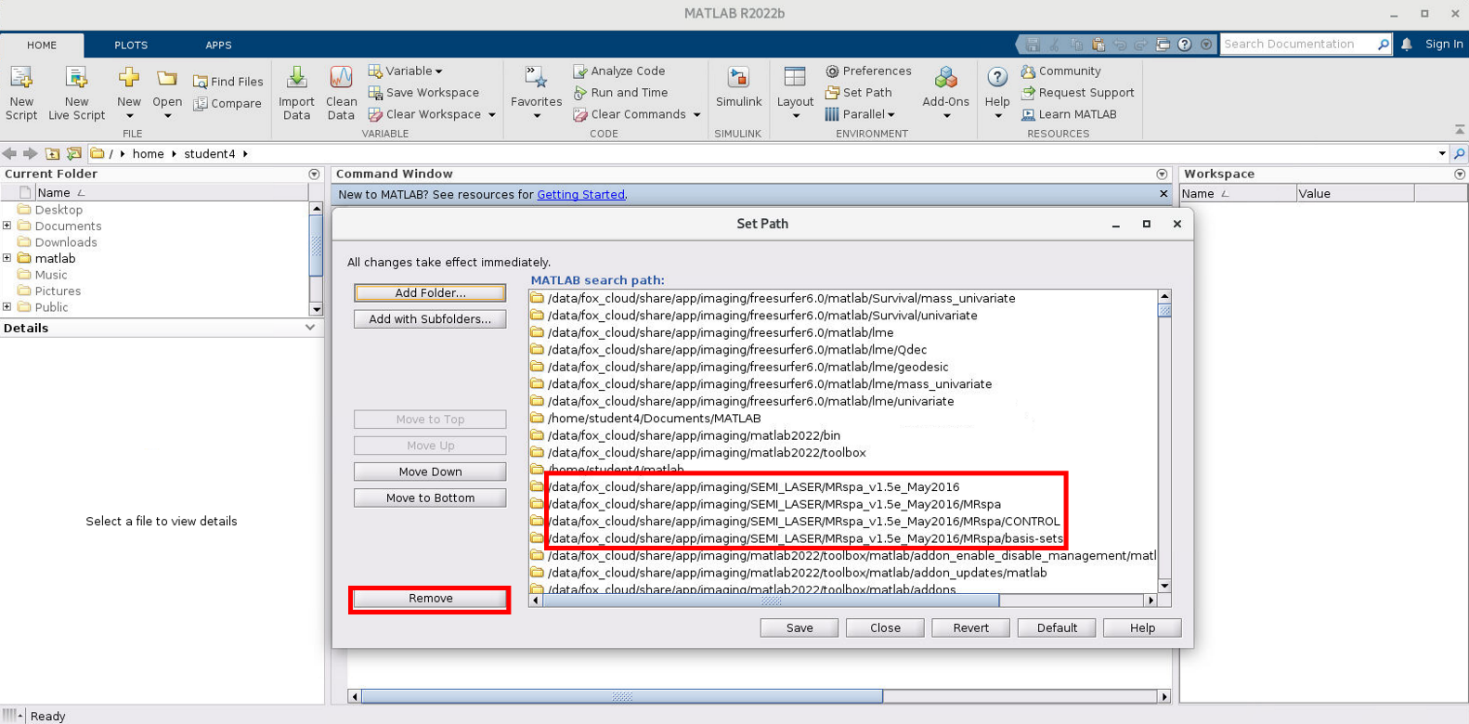

# Sequences

Sequence parameter pdfs can be found on:

/data/fox_cloud/share/app/imaging/MRS_ACTIVE/Documents/Sequences

**sLASER**

This guide is for analysing MRS data collected with the semi LASER or sLASER sequence (CMRR/FMRIB). We have several versions of sLASER at the 7T at WBIC, each one optimized for different voxel location. Key sequence parameters mostly don’t change, but please double check pdf’s parameters for your voxel.

# Software

To pre-process the data we use MRspa, a graphical interface that runs on MATLAB and has been developed by CMRR (www.cmrr.umn.edu/downloads/mrspa/). You can find the software (including basis sets and control files for fitting) and scripts on:

/data/fox_cloud/share/app/imaging/MRS_ACTIVE/Scripts_and_Software/Analysis

We use LC-Model to fit the data and quantify metabolite concentrations. Historically, LCModel was a proprietary software (until 2021) running on specific servers (FMRIB, HPHI). We now have it installed on the lab’s server.

**Server:** Please refer to the Server SOP.

# Pre-processing sLASER data

Each dataset from WBIC 7T includes both the unsuppressed water and metabolite scans in one folder.

The one presented here is the short version of main steps, for a more detailed-manual-like pipeline please check **APPENDIX 2** at the end of the **present document.**

## Preprocessing procedure

1. Launch MATLAB from terminal by typing: matlab
2. Include MRspa in the MATLAB path with subfolders (note: this is different to MEGA-PRESS/fitting with SEMI-LASER):

**/data/fox_cloud/share/app/imaging/SEMI_LASER/MRspa_v1.5e_May2016**

1. Launch MRspa by typing **MRspa**.
2. Select data. When loading dicom files, select the folder for Metabolite file only (i.e., leave eddy current correction file and water file blank).
3. Check for spectra to remove. Take a note of this spectrum’s number and re-load the data. Remove the spectrum before any other corrections. Proceed with steps 6-8. **Please double check which correction method you need to use for your study.** The ones listed below are general examples.
4. Run Eddy Current Correction with **default ECC2 + zero phase**
5. Run Frequency Correction with **default cross-correlation**
6. Run Phase Correction with **default least square**
7. Average FIDs.
8. Set %CSF to 0.
9. Save SPA file
10. **Write down linewidth** **or take a screenshot** – this values will not be shown anymore. This value corresponds to the water peak’s linewidth

## Fitting procedure

Please not that you might need to change both basis set and control file depending on your study. Those listed below are examples

1. Remove the current MRspa from the path and replace with subfolders: **/data/fox_cloud/share/app/imaging /SEMI_LASER /Adam_matlab_mrs_V1**
2. Launch MRspa by typing **MRspa_meas**.
3. Go to LCModel tab > Load spa file
4. Load 7T_poly_august_2016.BASIS
5. Tissue info: CSF=0
6. Choose poly_sept_2016.CONTROL
7. Run LCModel

# Data quality checks

A number of parameters are used to assess spectral quality and the quality of model fitting. These include:

1. Visual inspection of spectra
2. Water Linewidth
3. Spectral Linewidth (FWHM)
4. Signal-to-noise ratio (S/N or SNR)
5. Cramer-Rao lower bounds of the different metabolites (CRLB)
6. *Star on GABA concentration in LCModel output

**1. Visual inspection of spectra:** Visually inspect the raw data following Eddy Current Correction: are the spectra relatively aligned in the frequency dimension? Do you see spectra that are “sticking out” from the rest? These may be because of subject movement. Remove these before continuing with pre-processing. Sometimes these become more apparent after you attempt frequency correction. In this case remove these averages and redo the pre-processing steps.

Visually inspect the pre-processed data. For sLASER look at the final average. Do you observe large lipid contamination (around 1.5-2ppm)? Do you think there is water suppression residual that affects the spectral baseline?

**2. Water Linewidth:** This is calculated at the end of the pre-processing steps, when you save the “. spa” file. It indicates the FWHM of the water peak and is used to assess shimming quality. Beware that in all cases the water peak is a separate scan (even if the averages are collected with the same sequence when using sLASER). In principle, shimming should be the same between the metabolite scan and the water unsuppressed scan (we copy the adjust volume and measurement parameters after all), however between-scan subject motion will result in these being different (which you may not necessarily notice during data collection). While it’s a good index of shimming success, you should always look at spectral linewidth as well (FWHM, see below). If water linewidth is poor, then spectral FWHM will most definitely be poor as well. You should expect the water linewidth to be below 15Hz for successfully resolving GABA. As shimming varies with brain area, so will the water linewidth, so the range of values will be different for different voxels. Either FWHM or water linewidth can be reported in a paper, as long as correctly indicated in the methods. However, one should keep in mind that the water linewidth -in the case of the sequences used here- is calculated from a separate (although close in time) scan, with the caveats that this may entail (motion between metabolite and water scan, different scanner parameters set, etc).

**3. Spectral Linewidth (FWHM):** This is calculated following the LCmodel fitting step and can be found on the one-page PDF output. Values below 0.035ppm are very good, however as soon as FWHM is over 0.045ppm then the spectral resolution is low and this will be evident from poor CRLB values for the different metabolites as they won’t be successfully resolved. FWHM is tightly linked to water linewidth and shimming quality. In the majority of cases it will go together with poor fits for GABA and when it’s high you will notice that other indices of quality are low as well. As shimming varies with brain area, so will the spectral linewidth, so the range of values will be different for different voxels and it’s not wise to reject spectra based on the absolute FWHM value.

**4. SNR:** The signal to noise ratio is calculated following the LCmodel fitting step and can be found on the one-page PDF output. It is calculated as the ratio of the maximum in the spectrum (typically NAA) minus the baseline over 2*root-mean square (RMS) residuals. SNR for MEGAPRESS at 3T will always look relatively low due to the editing method, so you should expect a range of values between 20-30 for example for the occipito-temporal cortex. Look at the range of values you typically get for your voxel and reject outliers outside this range rather than having a strict number cut-off. There is no consensus on how SNR is calculated, resulting in a variety of methods and value ranges used across papers. SNR depends on: a) voxel size, b) brain region, c) field strength, d) number of transients collected. It is obvious that any variations in these parameters and their interactions can impact SNR, making it very hard to compare across different studies. A couple of ways we have used SNR in the past are i) as the LC Model output and ii) following the LC model manual, computing the ratio of the absolute NAA peak of the edited MEGA-PRESS spectrum over twice the rms of the whole range of the residuals (fitting with a basis spectrum that includes macromolecules to ensure no resonances remain in the residuals, see script *compute_SNR.m*.

(/data/fox_cloud/share/app/imaging/MRS_ACTIVE/Scripts_and_Software/Analysis)

**5. CRLB:** Cramer-Rao lower bounds of variance give the lowest possible variance that can be achieved by an estimator and is an indication of fitting quality. CRLB are calculated following the LCmodel fitting step and can be found on the one-page PDF output as CRLB% for each metabolite. Although generic thresholds for CRLB% are widely used these can introduce errors into sample estimate (see: Kreis, 2016, PMID: 25753153) due to changes in metabolite concentration. While in the past, high CRLB values were used to exclude spectra, now this method is frowned upon and for good reason: if you are measuring a metabolite that you expect to change, a decrease in its concentration will result in higher CRLB values, while an increase in lower CRLB values, as more of the metabolite will mean a better fit. To avoid biasing your data towards higher metabolite concentrations (either in the case of change in metabolite concentration or comparing populations that are expected to differ in a specific metabolite), you could reject outliers based on the range of values in your sample instead of using an arbitrary cut-off. Further, it has been recommended to use absolute CRLB values (=%CRLB x absolute concentration) (Kreis, 2016), both for rejecting poor quality data and explaining data quality variability across participants.

Having said that, when the CRLB values are too high, then this indicates failure to fit a metabolite (either because the spectral resolution is poor so it cannot be resolved, in which case it will probably be accompanied by high linewidth values, or because the concentration of the metabolite is so low that it cannot get measured, as for example in the case a voxel contains mostly CSF rather than GM/WM). When the fit fails completely the value is 999, but anything above 60-70 should be considered unreliable.

Very low values of CRLB should be viewed with caution and always together with visual inspection of the fit. The range of values will vary massively with different metabolites, voxels, scanner strength and sequence. For example, GABA CRLB values for 7T sLASER 2x2x2cm voxel on IPS can vary from 13-45, while GABA CRLB for 3T MEGAPRESS 2x2x2.5cm voxel on LOC can be between 5-10, with all datasets in these cases being acceptable and without meaning that the 3T MEGAPRESS data fit better than the 7T sLASER data. Again, the suggestion is to use as a range of values specific for your metabolite/voxel/sequence/scanner strength and exclude outliers.

**6. *Star on GABA concentration in LCModel output:** Rarely, LCModel might display the metabolite concentration in bold red font. This means that the concentration is slightly higher (+ preceding) or lower (- preceding) than expected. Double check this data point in relation to the sample mean/SD/range.

# After pre-processing

For both MEGApress and SEMILaser data there are several steps that need to be performed after pre-processing:

1. Creating MRS-Mask

This is needed both for the purpose of tissue correction and to double check the anatomical voxel position.

You need a structural scan and a spectroscopy file. Naturally, the two would need to be aligned and coming from the same scan, assuming the participant hasn’t moved in between.

/data/fox_cloud/share/app/imaging/MRS_ACTIVE/Scripts_and_Software/Full_analysis_pipeline_MATLAB/scripts/mrs_mask_and_anatomical/b_make_mrs_mask

1. Get voxel position

After generating the MRS voxel mask, you can use it to calculate voxel’s anatomical coordinates. This is useful to 1) double check that your voxel was in the correct location 2) it corresponds to the position you have chosen in the scanner 3) to identify outliers both within and across participants based on coordinates mean and SD

/data/fox_cloud/share/app/imaging/MRS_ACTIVE/Scripts_and_Software/Full_analysis_pipeline_MATLAB/scripts/mrs_mask_and_anatomical/c_get_voxel_position

1. Find voxel overlap

After generating the MRS voxel mask, you can overlap it with an anatomical atlas to double check your voxel is in the anatomical desired position. Depending on the study you might use different atlases as a reference. This step is usually performed in MNI space.

/data/fox_cloud/share/app/imaging/MRS_ACTIVE/Scripts_and_Software/Full_analysis_pipeline_MATLAB/scripts/mrs_mask_and_anatomical/d_find_visual_voxel_overlap_average_voxel_average_anatomical

1. Voxel segmentation

Before being able to segment your voxel, you need to segment the whole anatomy using FreeSurfer. This step will require several hours depending on your anatomical scan details (3 or 7T, voxel size). We usually run Freesurfer recon-all with high resolution options for 7T (please check **Appendix 2** for this)

* + 1. Segment FreeSurfer output. By default, FreeSurfer does not create binary segmentations for each tissue (GM, WM, CSF), so we need to binarize these masks first. /data/fox_cloud/share/app/imaging/MRS_ACTIVE/Scripts_and_Software/Full_analysis_pipeline_MATLAB/scripts/voxel_segmentation/a_segment_freesurfer_output
    2. Mask Free Surfer segmentation. You need to mask your whole brain segmentation with the voxel mask to calculate tissue probabilities later used to perform tissue correction.

/data/fox_cloud/share/app/imaging/MRS_ACTIVE/Scripts_and_Software/Full_analysis_pipeline_MATLAB/scripts/voxel_segmentation/c_mask_freesurfer_segmentation

1. Extracting and correcting metabolites values

Metabolites values can be found both on the .pdf output from LC Model (easier to visualize) and in the relative .COORD file. To import metabolites values in Matlab you can use the functions import_LCM_semilaser or import_LCM_MEGApress that can be found in:

/data/fox_cloud/share/app/imaging/MRS_ACTIVE/Scripts_and_Software/Full_analysis_pipeline_MATLAB/scripts/data_prep_scripts_before_and_after_analysis

1. Tissue-correction

There are several ways to perform tissue-correction on data. ‘MRSData’ is a class of functions that can be run on either type of MRS data (Semilaser or MEGApress, 3T and 7T), and can be found in:

/data/fox_cloud/share/app/imaging/MRS_ACTIVE/Scripts_and_Software/Full_analysis_pipeline_MATLAB/scripts/analysis_class

The most important function included in this class is the one to perform the alpha correction; you need to have run all the previous steps before.

# Tissue correction

There are various methods for tissue correction, without a consensus having been reached about which one is more appropriate. Please note that this is just a conceptual overview, you can find the steps and codes to proceed in each sequence more detailed pipeline file.

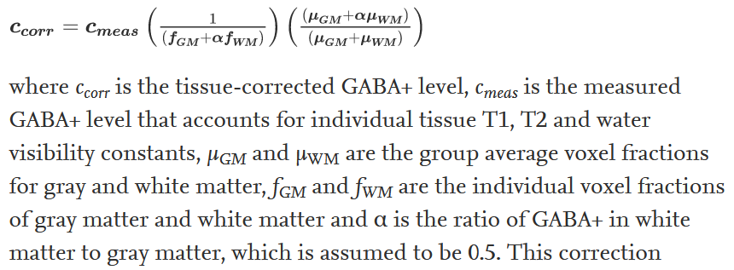Methods we’ve used include i) making no assumptions about the distribution of GABA or Glutamate between grey and white matter and regressing out the percentage of CSF in the voxel from different relational analyses, ii) making no assumptions about the distribution of GABA or Glutamate between grey and white matter and dividing the concentration by 1-CSF (=GM+WM percentage), and iii) considering the concentration of GABA in the grey matter to be double that of white matter and using the so-called α-correction (Porges et al, 2017):

While one may consider to use multiple tissue correction methods in a publication, this is not recommended, unless inevitably prompted by a curious reviewer

|  |  |  |  |  |  |  |  |  |  |  |
| --- | --- | --- | --- | --- | --- | --- | --- | --- | --- | --- |
| **Voxel** | **Scanner Strength** | **Sequence** | **Voxel size**  **(cm)** | **Water linewidth** | **Spectral FWHM** | **SNR** | **GABA CRLB** | **GABA / water** | **GABA**  **/CR NAA** | **Source/paper** |
| LOC | 3T  (CBU) | MEGAPRESS | 2x2x2.5 | 7-9Hz  (<10Hz) | 0.021 - 0.057 | 20-30 | 5-10 | 1.0-1.9 | 1.0-1.9 | tDCs/MRS  Frangou et al, in prep |
| LOC | 3T  (WBIC) | MEGAPRESS | 2x2x2.5 | 7-9Hz  (<10Hz) | 0.02-0.05 | 20-27 | 4-6 | 2-3 | 1.4 – 1.8 | Long-term training  Ziminski et al, in prep |
| IPS | 3T  (WBIC) | MEGAPRESS | 2x2x2.5 | 4-7 Hz (<8Hz) | 0.015-0.043 | 20-30 | 4-6 | 2-3 | 1.4 – 1.8 | Long-term training  Ziminski et al, in prep |
| LOC | 7T  (FMRIB) | sLASER | 2x2x2 | 12-17Hz  (<15Hz) | 0.025-0.045 | 50-70 | 20-50 | 2.1-3.0 | 0.1-0.2 | Frangou et al, 2019  Nat.Communications |
| IPS | 7T  (FMRIB) | sLASER | 2x2x2 | 11-13Hz  (<15Hz) | 0.025-0.030 | 50-70 | 15-40 | 1.4-2.5 | 0.05-0.15 | Frangou et al, 2019  Nat.Communications |
| V1 | 7T  (WBIC) | sLASER | 2x2x2 | ~14Hz | ~0.030 | ~60 | ~15 | ~2.7 | ~2.5 | Pilots |
| LOC | 7T  (WBIC) | sLASER | 2x2x2 | ~17Hz | ~0.035 | ~80 | ~10 | ~3.4 | ~3.4 | Pilots |
| IPS | 7T  (WBIC) | sLASER | 2x2x2 | ~15Hz | ~0.030 | ~70 | ~19 | ~1.8 | ~1.8 | Pilots |
| V1 | 3T  (CBU) | MEGAPRESS | 2.5 iso | 5.5-9Hz | 0.019-0.067 | 20-30 | 2-8 | 1.6-2.4 | 1.1-1.7 | Adaptation dataset,  Karlaftis et al, 2021 |
| PCC | 3T  (CBU) | MEGAPRESS | 2.5 iso | 5.5-7Hz | 0.014-0.029 | 20-30 | 2-8 | 1.4-2.3 | 1.2-1.9 | Adaptation dataset,  Karlaftis et al, 2021 |
| DLPFC | 3T  (CBU) | MEGAPRESS | 2.5 iso | 6-9Hz | 0.014-0.050 | 20-30 | 2-8 | 1.2-1.8 | 1.1-1.7 | Adaptation dataset,  Karlaftis et al, 2021 |

# Table: example values of data quality indices

# MRS-rsfMRI-behaviour relational analyses

## MRS main effects

**Single MRS measurement (resting MRS)**

Main analyses

Compare neurotransmitter concentrations between populations (independent groups t-test or ANOVA if multiple groups) or between brain regions (correlation, see notes in section J).

**Multiple MRS measurements during task (functional MRS)**

Main analyses

Test for changes in neurotransmitter concentrations across time (repeated measures ANOVA, use linear mixed effects models if you are missing measurements but cannot afford removing the subjects).

Controls

1. Reference: repeat analysis for a different reference for the neurotransmitter, for example GABA/NAA or GABA/Cre vs GABA/Water. Also, show no change in the concentration of the reference metabolite over time by repeating the analysis for the reference metabolite.
2. Neurotransmitter specificity: Repeat analysis for other neurotransmitters (e.g. Glu).
3. Data quality: show no change in linewidth (BOLD effects), CRLB or SNR
4. Order effects: if multiple MRS voxels were collected in a randomised order, show that the results are not driven by the order in which the voxels were collected by including order as a factor in the ANOVA.

## MRS with behaviour

**Single MRS measurement (resting MRS)**

Main analyses

Correlation of neurotransmitter concentration with behavioural measure. If you have multiple neurotransmitters of interest or multiple regions of interest, you can run a multiple regression instead of multiple correlations with the neurotransmitter concentrations as predictors (beware of collinearity!). If a neurotransmitter concentration may relate to multiple behavioural outcomes, you can run a multivariate regression. See section J for notes on the different analysis options.

1. Reference: repeat analysis for a different reference for the neurotransmitter, for example GABA/NAA or GABA/Cre vs GABA/Water. If this is marginal, try combining the control for reference and tissue.
2. Account for tissue variability: See section F for more details.
3. Neurotransmitter specificity: Repeat correlation for other neurotransmitter (e.g. Glu) or build a regression model with both neurotransmitters as predictors or, alternatively, regress Glu from GABA and repeat correlation with the residuals.
4. Data quality: regress out variability in linewidth, CRLB or SNR from neurotransmitter measurements.

**Multiple MRS measurements during task (functional MRS)**

Main analyses

Correlation of change in neurotransmitter concentration with behavioural measure. If you have multiple neurotransmitters of interest or multiple regions of interest, you can run a multiple regression instead of multiple correlations with the changes in neurotransmitter concentrations as predictors (beware of collinearity!). If a change in neurotransmitter concentration may relate to multiple behavioural outcomes, you can run a multivariate regression. See section J for notes on the different analysis options.

Controls

1. Reference: repeat analysis for a different reference for the neurotransmitter, for example GABA/NAA or GABA/Cre vs GABA/Water. If this is marginal, try combining the control for reference and tissue.
2. Account for tissue variability: See section F for more details.
3. Neurotransmitter specificity: Repeat correlation for other neurotransmitter (e.g. Glu) or build a regression model with both neurotransmitters as predictors or, alternatively, regress Glu from GABA and repeat correlation with the residuals.
4. Data quality: regress out change in linewidth (BOLD effects), CRLB or SNR from neurotransmitter measurements.
5. Baseline effects: compute %change for neurotransmitters to show effects not driven by baseline or regress out baseline from behaviour.

## MRS with rsfMRI

**Single MRS measurement (resting MRS)**

Main analyses

Correlation of neurotransmitter concentration with rsfMRI connectivity. If you have multiple neurotransmitters of interest or multiple regions of interest, you can run a multiple regression instead of multiple correlations with the neurotransmitter concentrations or rsfMRI connections as predictors (beware of collinearity!). See section J for notes on the different analysis options.

1. Reference: repeat analysis for a different reference for the neurotransmitter, for example GABA/NAA or GABA/Cre vs GABA/Water. If this is marginal, try combining the control for reference and tissue.
2. Account for tissue variability: See section F for more details.
3. Neurotransmitter specificity: Repeat correlation for other neurotransmitters (e.g. Glu) or build a regression model with both neurotransmitters as predictors or, alternatively, regress Glu from GABA and repeat correlation with the residuals.
4. Data quality: regress out variability in linewidth, CRLB or SNR from neurotransmitter measurements.
5. rsfMRI specificity: Repeat analysis for a different seed or target.

**Multiple MRS measurements during task (functional MRS)**

Main analyses

Correlation of change in neurotransmitter concentration with rsfMRI connectivity. If you have multiple neurotransmitters of interest or multiple regions of interest, you can run a multiple regression instead of multiple correlations with the changes in neurotransmitter concentrations or the rsfMRI connections as predictors (beware of collinearity!). See section J for notes on the different analysis options.

1. Reference: repeat analysis for a different reference for the neurotransmitter, for example GABA/NAA or GABA/Cre vs GABA/Water. If this is marginal, try combining the control for reference and tissue.
2. Account for tissue variability: See section F for more details.
3. Neurotransmitter specificity: Repeat correlation for other neurotransmitters (e.g. Glu) or build a regression model with both neurotransmitters as predictors or, alternatively, regress Glu from GABA and repeat correlation with the residuals.
4. Data quality: regress out change in linewidth (BOLD effects), CRLB or SNR from neurotransmitter measurements.
5. Baseline effects: compute %change for neurotransmitters to show effects not driven by baseline or regress out baseline from connectivity.

## rsfMRI with behaviour

Main analyses

Correlation of behavioural measure with rsfMRI connectivity. If you have multiple connections of interest, you can run a multiple regression instead of multiple correlations with the rsfMRI connections as predictors (beware of collinearity!). See section J for notes on the different analysis options.

Controls

rsfMRI specificity: Repeat analysis for a different seed or target.

#### *Getting a measure of rsfMRI connectivity*

* ROI based analysis: from MRS mask to equally sized target *(usually this one works)*
* Seed-based analysis: from MRS mask to the whole brain
* Seed-based analysis: from MRS mask to the whole brain + GABA as covariate
* ICA-based analysis: from IC that overlaps with MRS mask to other IC

# Useful notes on different analyses

**Correlating two variables**

|  |  |
| --- | --- |
| Outliers present | No outliers |
| * Robustfit * Remove outliers (boxplot rule, Cooke’s distance, Robust Correlation Toolbox) + run Pearson’s | * Robustfit * Pearson’s |

Note: Robustfit will return beta-weights, as it’s a regression rather than a correlation. In this case, you need to convert the t-statistic to an r-value using the following formula:

r = sign(stats.t(i+1))*sqrt(stats.t(i+1)^2/(stats.t(i+1)^2+stats.dfe));

where i is the predictor of interest (note that the first predictor is always the intercept).

For running correlations with different methods, see script *run_correlations.m*.

**Significantly different correlations (two groups)**

Fisher’s Z: <http://vassarstats.net/rdiff.html>

Alternatively, run a multiple regression model in SPSS with group x predictor → outcome showing a significant interaction between the group and predictor.

**Significantly different correlations (one group)**

Steiger’s Z: <http://quantpsy.org/corrtest/corrtest2.htm>

Alternatively, run a multivariate regression model in SPSS (predictor → multiple outcomes).

**Regressing out a nuisance variable from predictor**

X: predictor, Y: outcome, Z: nuisance variable

MATLAB: [~,~,res]= regress(X, [Z, ones(size(Z,1),1)]);

[r,t,p] = Pearson (res, Y); (see number 1 for correlations)

If you wish to remove the effect of the nuisance variable from both the predictor and the outcome, then you repeat the regress function for Y,Z and then correlate the two sets of residuals.

**Removing “baseline” effects**

Calculate % change ((post-pre) / pre) rather than (post-pre) to test for relationships of the relative change without worrying about it all being driven by the baseline. If the baseline is not correlated with the (post-pre) then you can also use it in a multiple regression. Finally, you can use method 4 to remove baseline effects, i.e. regress out the “pre” measurement from the change (post-pre) and then run the correlations.

**Multiple predictors - one outcome**

|  |  |
| --- | --- |
| Predictors correlate | Predictors independent |
| * Partial correlation * PLS | * Robustfit * Multiple regression (if no outliers) |

**One predictor - multiple outcomes**

Multivariate regression in SPSS. If outliers are present, they will be detected with the Cook’s distance in SPSS. See examples and tips here:

<https://www.sheffield.ac.uk/polopoly_fs/1.531431!/file/MASHRegression_Further_SPSS.pdf>

**Mediation or moderation models**

Use PROCESS in SPSS. Download from here: <https://www.processmacro.org/index.html> (no admin rights needed). Useful and typical models:

<http://www.regorz-statistik.de/en/process_3_model_templates.html>

Mediation models can also be run in JASP.

# Appendix 1-Notes on MRspa

Get Data from MRspa Plot

It is possible to get the data from the MRspa plot with:

h = findobj(gca, ‘Type’, ‘line’);

x = get(h, ‘Xdata’);

y = get(h, ‘Ydata’);

Functions for LCModel

https://github.com/chenkonturek/MRS_MRI_libs contains useful functions for reading data from LCmodel output files. A copy can be found at: gitlab.developers.cam.ac.uk/psychol/abg/pipeline_mrs/Scripts and U:\Cambridge\MRS\Scripts_and_Software\Analysis.

MRS Voxel position tags in the DICOM file

For sLaser to find voxel dims look for params:

Shimming voxel:

sAdjData.sAdjVolume.dThickness

sAdjData.sAdjVolume.dPhaseFOV

sAdjData.sAdjVolume.dReadoutFOV

actual voxel:

sSpecPara.sVoI.dThickness

sSpecPara.sVoI.dPhaseFOV

sSpecPara.sVoI.dReadoutFOV

# Appendix 2-MRspa pipeline

7T MRS data consists of water and metabolite data that require several operations in order to correct unwanted artefacts. Such artefacts are related to participant motion, as well the drift of the scanner’s centre frequency, respiration, heartbeat, etc.

The scripts and paths used in this SOP are only for reference. You will most likely need to change these to tailor them to your study.

/data/fox_cloud/share/app/imaging/MRS_ACTIVE/Scripts_and_Software/Full_analysis_pipeline_MATLAB/scripts/data_prep_scripts_before_and_after_analysis

Data can be analysed on Server. In both cases, run the scripts trough Server and set up your path in Matlab accordingly.

**MRspa preprocessing**

Each dataset from WBIC 7T includes both the unsuppressed water and metabolite scans in one folder.

Usually, MRS data is analysed on Server where all necessary tools are available. The same tools are used by other colleagues running MRS analysis so make sure you do not change any scripts on Server. If you still need to make changes, make a copy of the altered scripts and save them with a new name for further use in your analysis.

To analyse your data:

1. 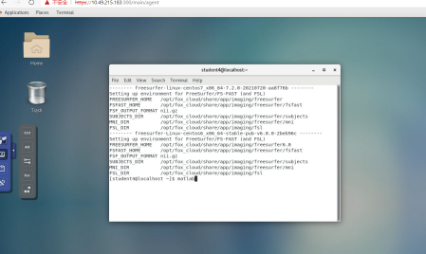connect to Server. Open MATLAB through the terminal -> right-click mouse -> ‘Open Terminal’ -> type Matlab.
2. 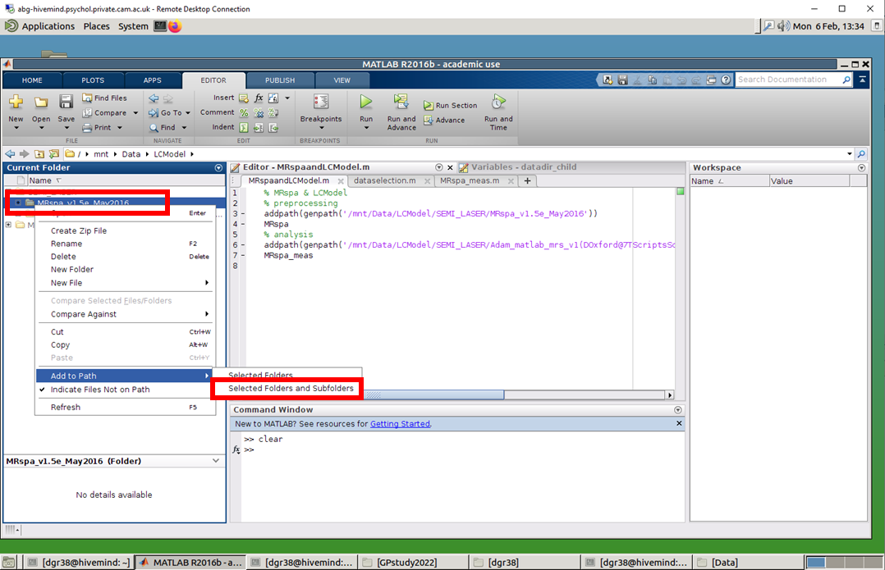Add the following folder (with subfolders) to your path: /data/fox_cloud/share/app/imaging/SEMI_LASER/MRspa_v1.5e_May2016. Make sure the path does not have another version of MRspa previously added (The folder may have been existed, but remove it in case of any error).
3. 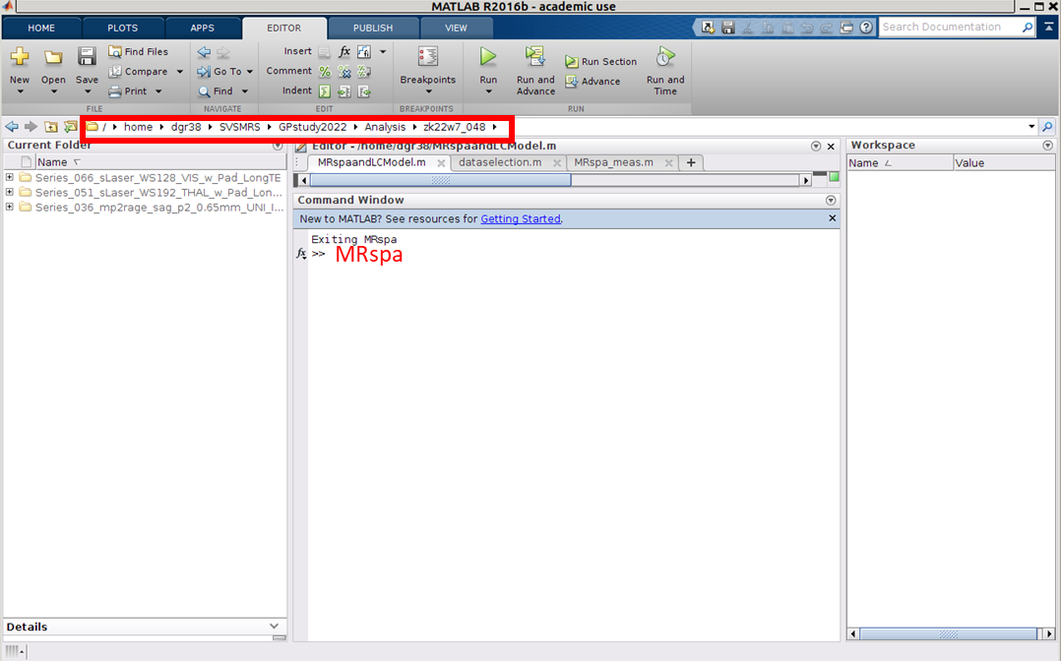Run in MATLAB command window the command ‘MRspa’ after the current directory of the MATLAB interface was changed to the current dataset folder.

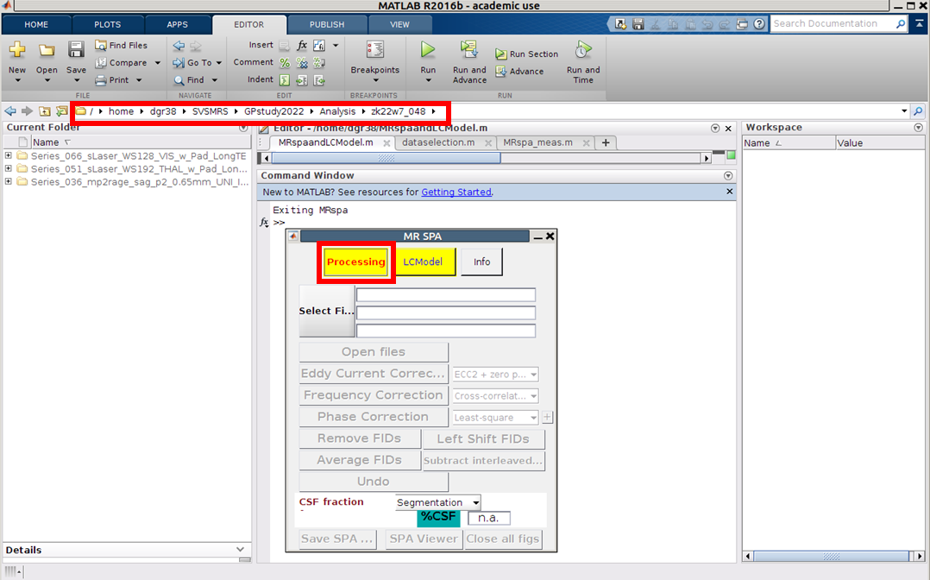A new window opens up. It corresponds to the preprocessing stage.

1. 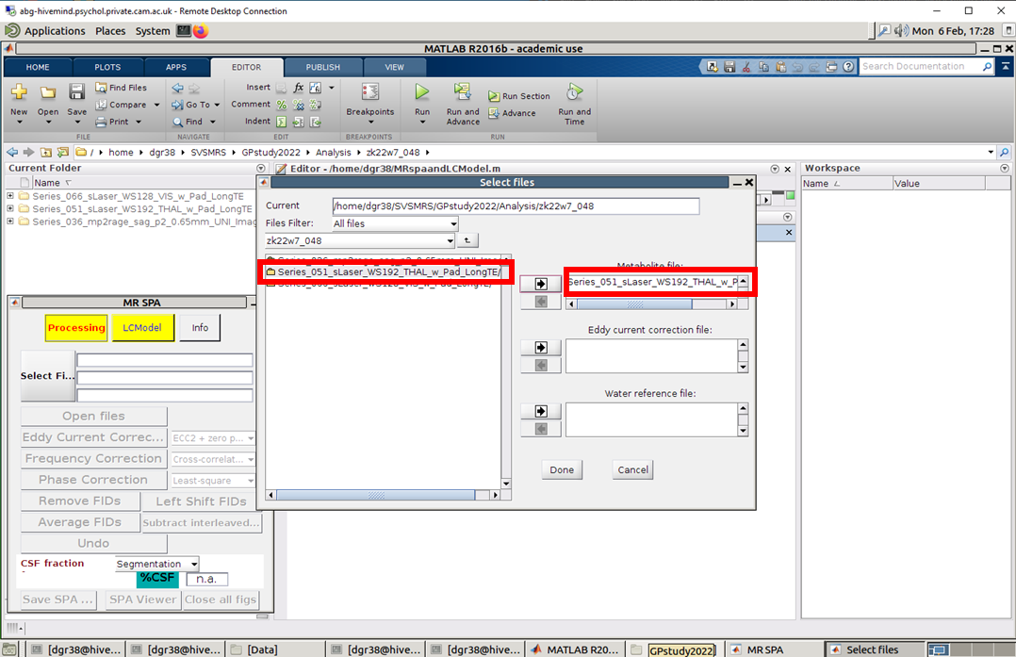Start by selecting the dataset. The name of the data file usually contains the voxel name, the word ‘sLaser’, etc. Click on the file name on the left then hit the button with the arrow ( 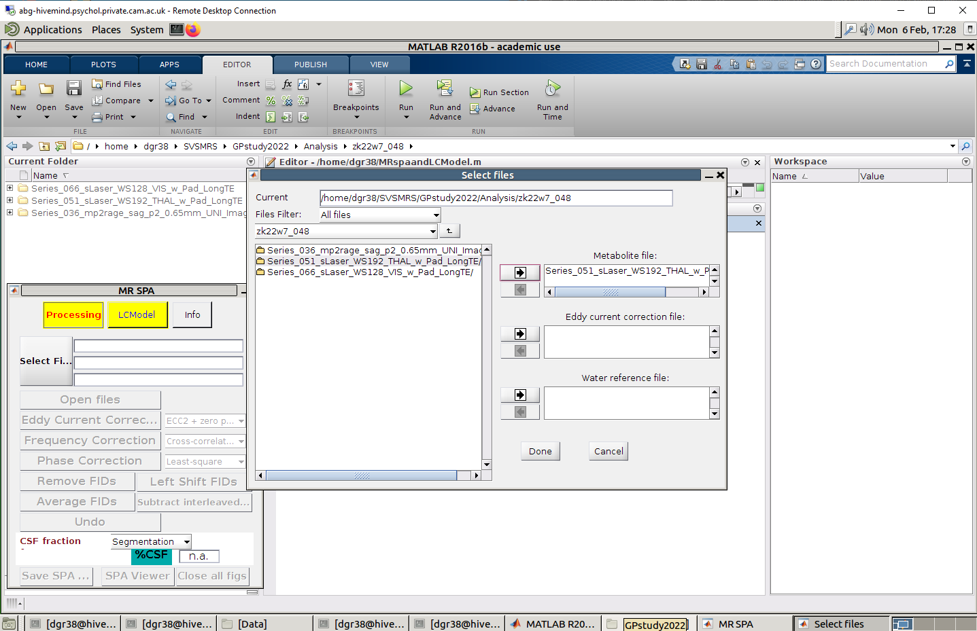) and the name of the file selected will come up on the right column under ‘Metabolite file’. Click ‘Done’.
2. 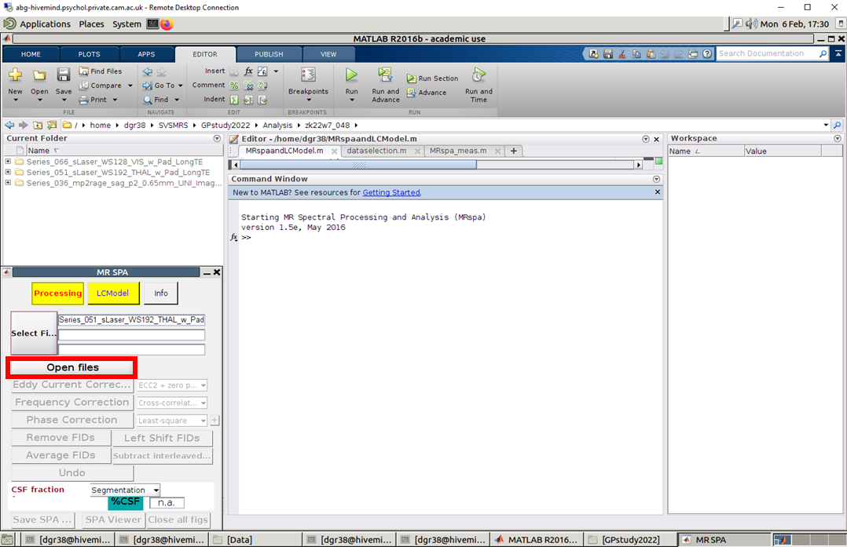Read the file selected by clicking ‘Open files’.

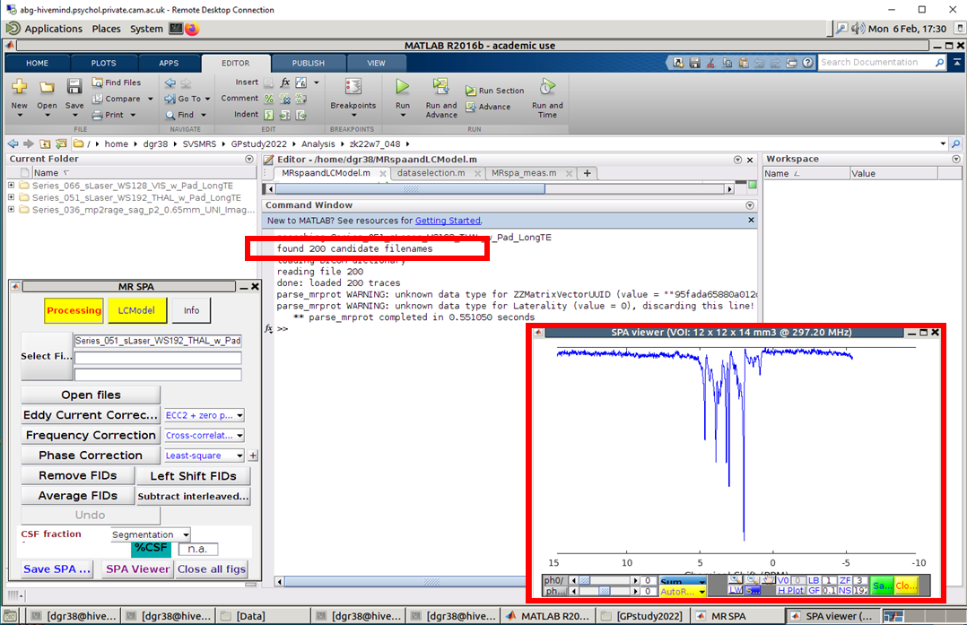You will see now the number of total DICOM averages/FIDs that are read for each dataset (i.e. 200 for the example below). The ‘SPA viewer’ will also open up and will display the averaged spectrum without any corrections applied

1. The step ‘Remove FIDs’ is necessary if only there are bad averages (please check the ppt with bad averages for reference). Note: there are usually 8 water averages acquired so the total number of averages identified will be x+8 averages (96+8 or 160 + 8).

To check the appearance of the spectra and assess the existence of bad averages change the viewing mode to ‘Individual’ so you can see all averages and identify bad ones. Check the red box below and change the selected mode from ‘Sum’ to ‘Individual’. Any averages that look shifted or abnormal should be removed.

Please note that the pictures below are mostly illustrated in the mode of ‘Stacked’, however, we usually use the mode of ‘Individual’.

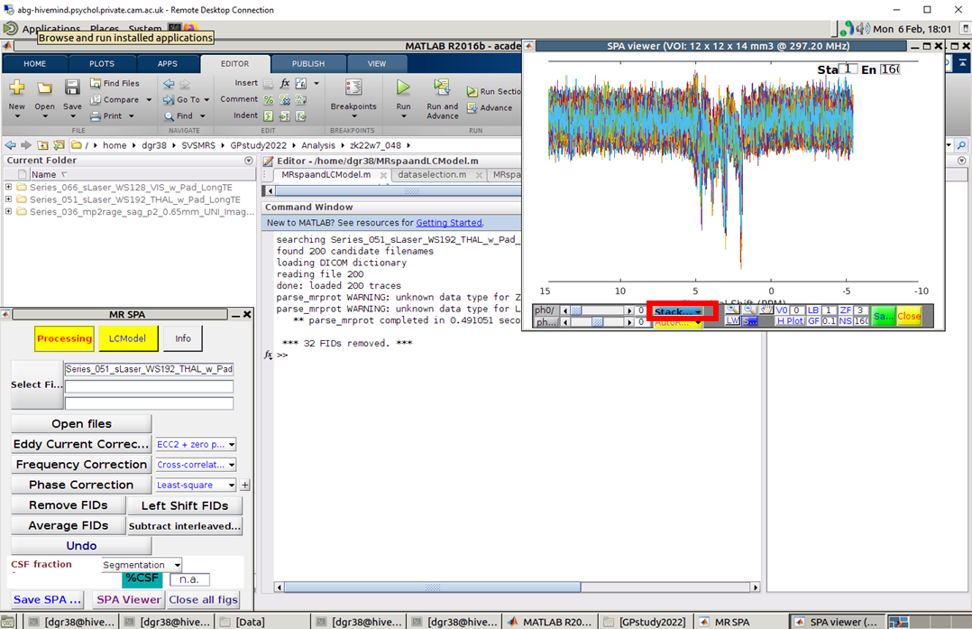

If the Individual mode doesn’t show any bad averages, then you don’t need to remove any file. If you see any unusual spectra then you need to identify the correct FID numbers.

The FID numbers identified will be further removed.

Hit ‘Remove FIDs’; a new window opens up. Select the FID numbers to be removed on the left and then press the arrow button (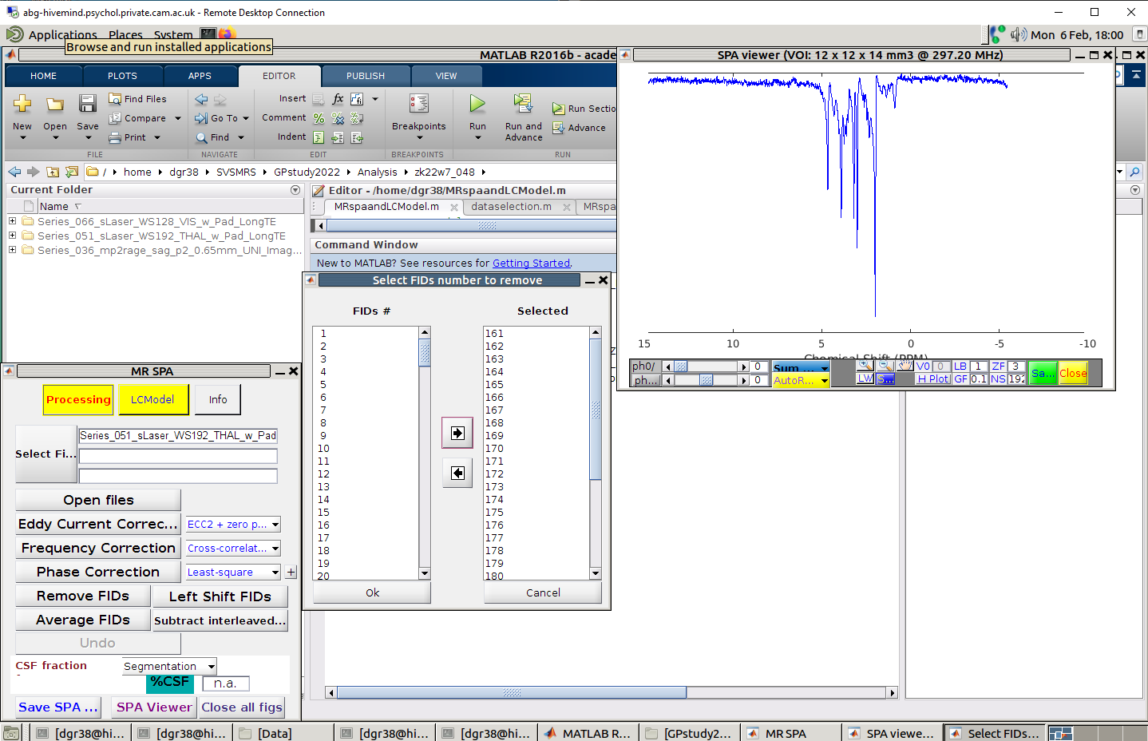) to transfer the numbers from the ‘FIDs #’ column to the ‘Selected’ column. Then click ‘Ok’.

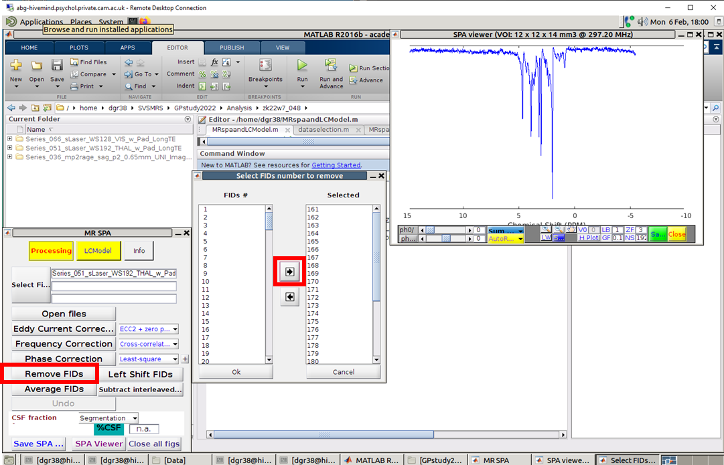

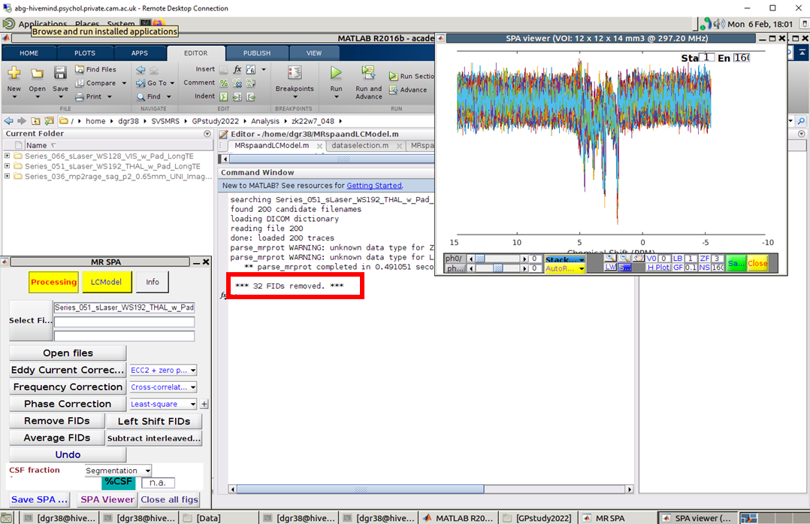At the end, a message is displayed with the number of FIDs removed.

1. 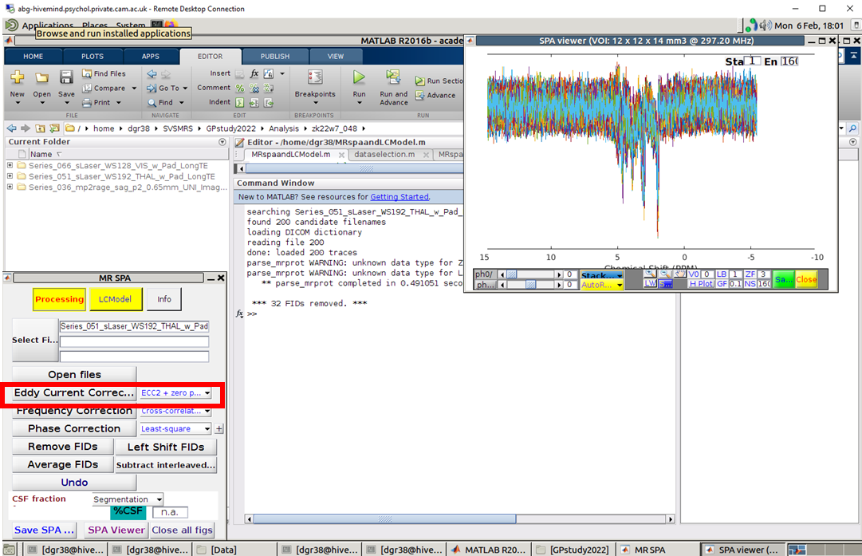Run ‘Eddy Current Correction’ with default option ‘ECC2 + zero phase’.

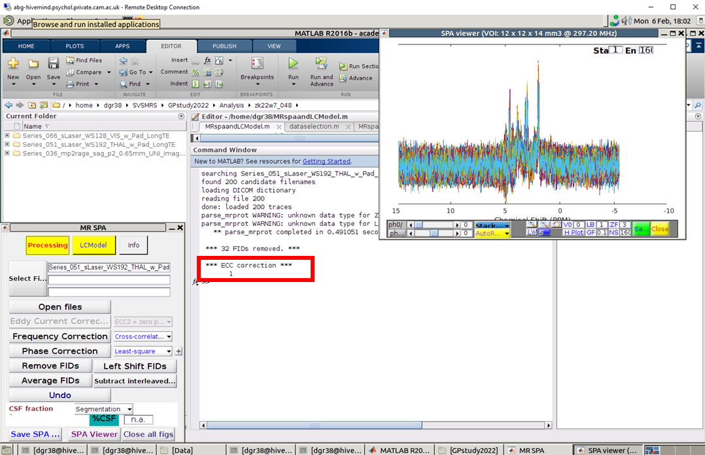A confirmation message is displayed at the end of this step. The spectra in the SPA viewer will also change slightly.

1. 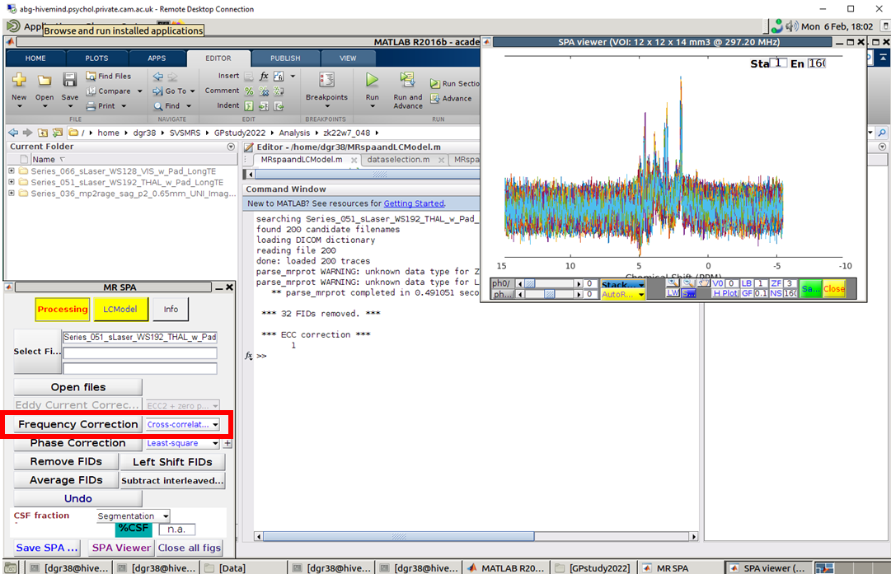Run ‘Frequency Correction’ with default option ‘Cross-correlation’.

A figure will be output with the spectra before and after.

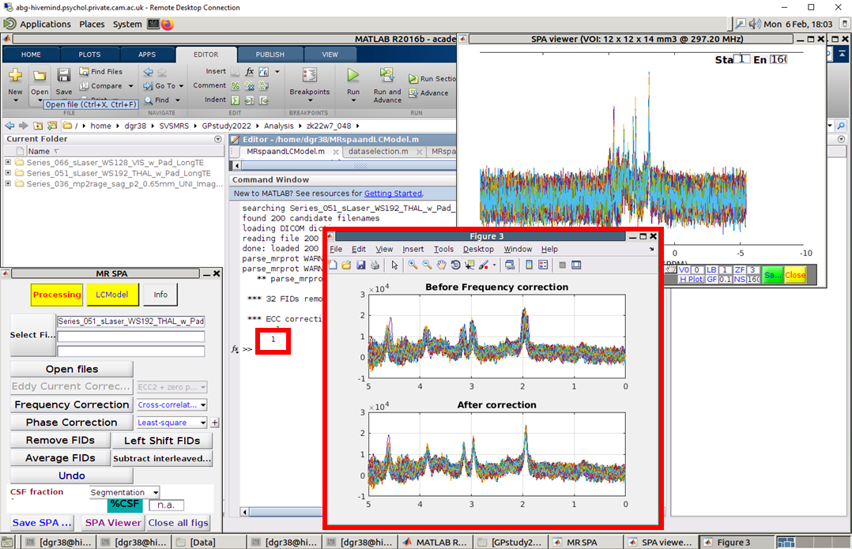The number ‘1’ will be output to confirm this step was also completed.

1. 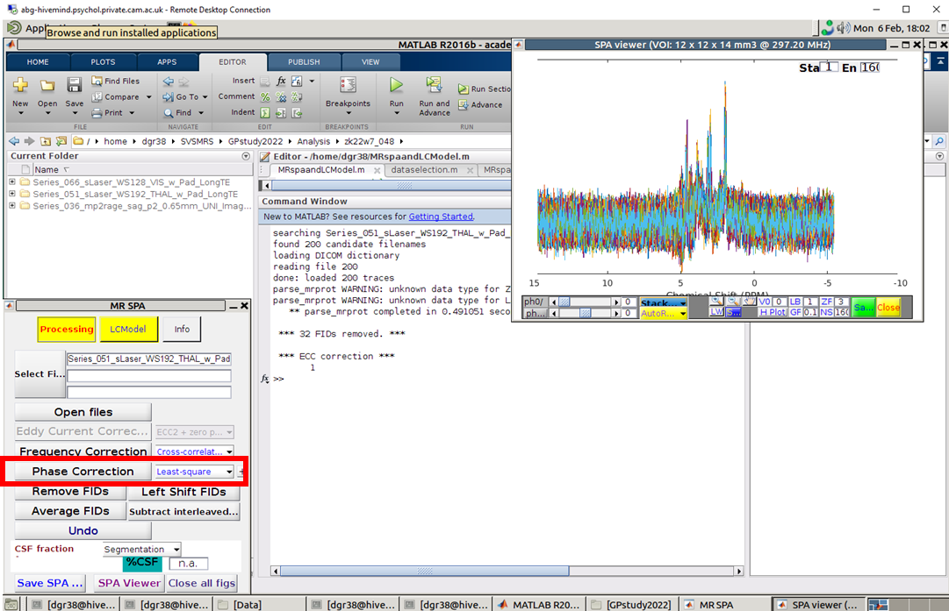Run ‘Phase Correction’ with the default option ‘Least-square’.

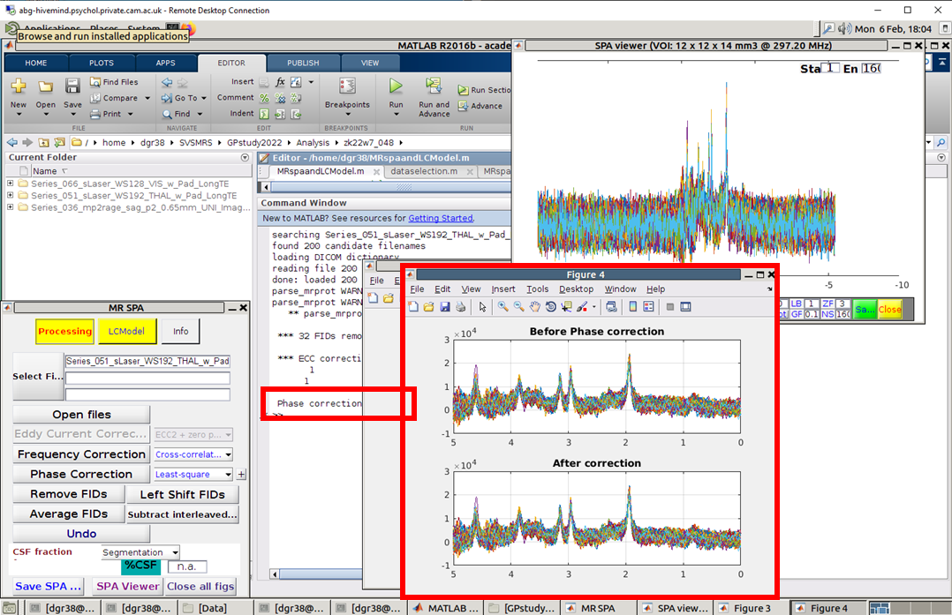A figure will be output with the spectra before and after. The message ‘Phase correction: processing (be patient…)’ will be displayed.

1. 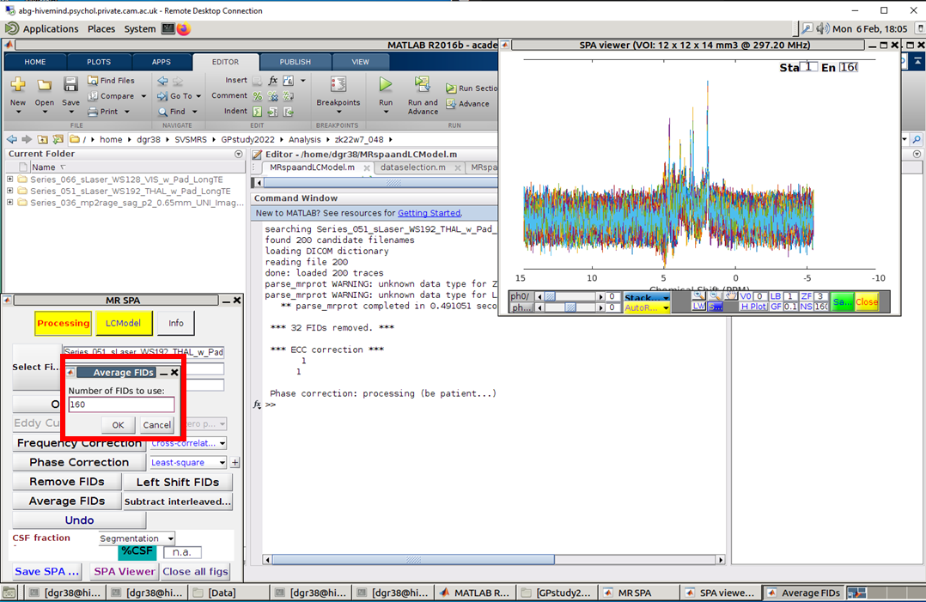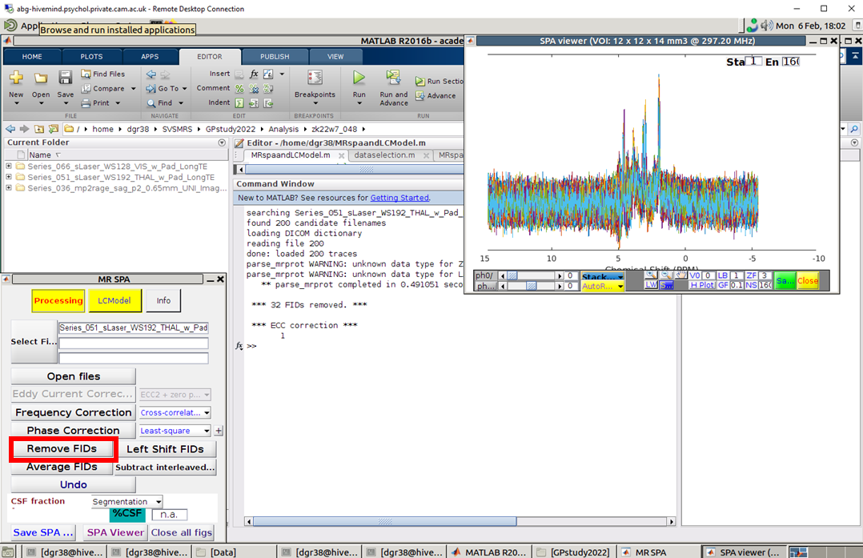Run ‘Average FIDs’ with the total number of acquired averages. Insert the total number of FIDs to average. (i.e. total number of averages is 200 of which 8 are water FIDs, 32 were removed and in total now we are left with 160 – the total number should always come up in the field ‘End’ on top right corner of the SPA viewer).

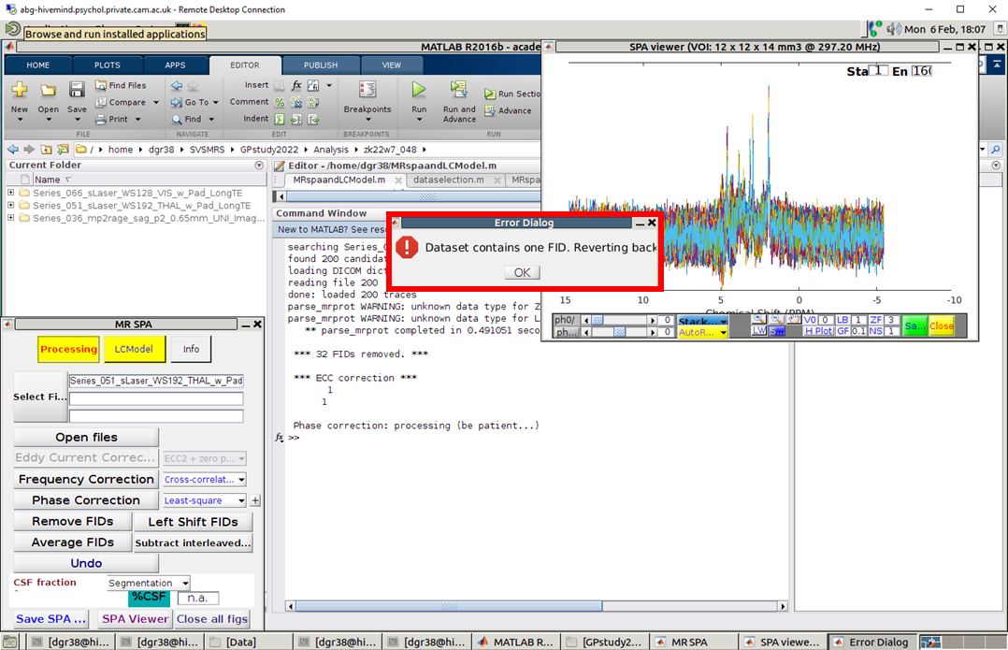A pop-up window opens up if visualisation mode was ‘stacked’. After averaging there will be a single average to view, not multiple. This is normal and expected.

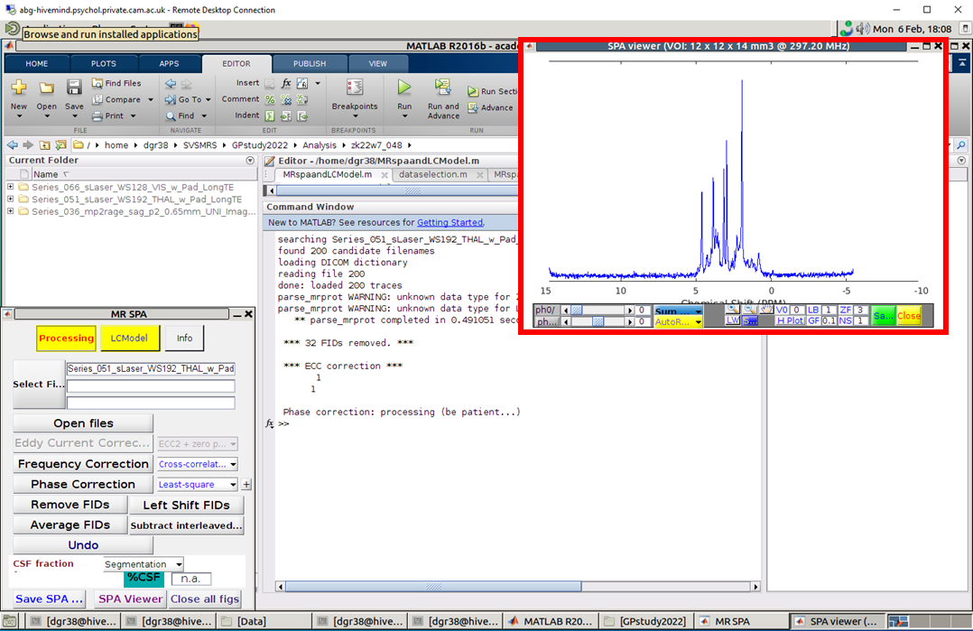The final averaged spectrum is updated in the SPA viewer.

1. 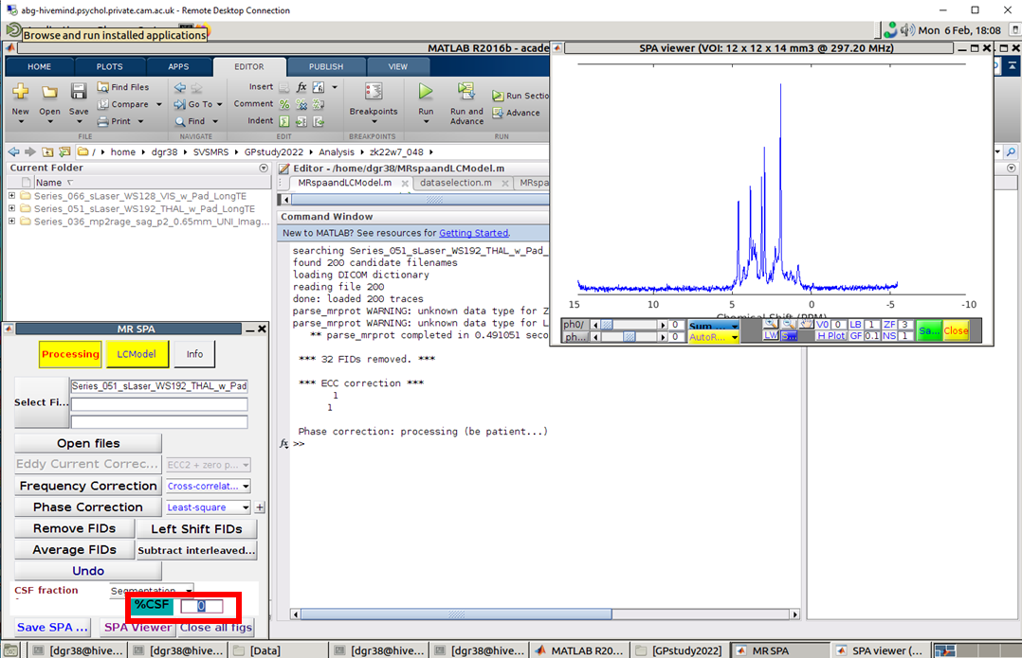Set CSF fraction to zero.
2. 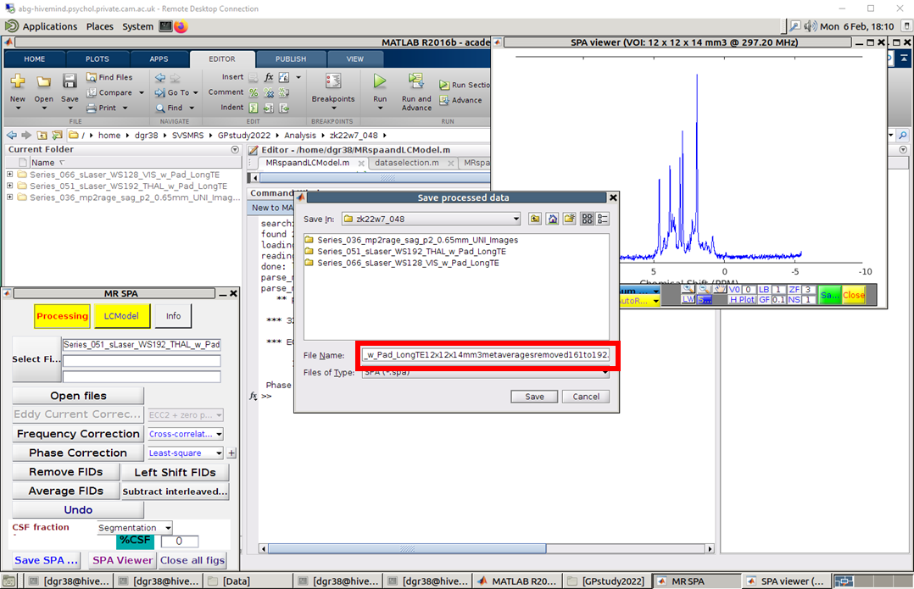Save the SPA file with the same name as the dataset; you can include in the file name also the voxel size and number of removed averages, as shown below. Note: the voxel size can be found in the figure title of the plotted spectrum.
3. 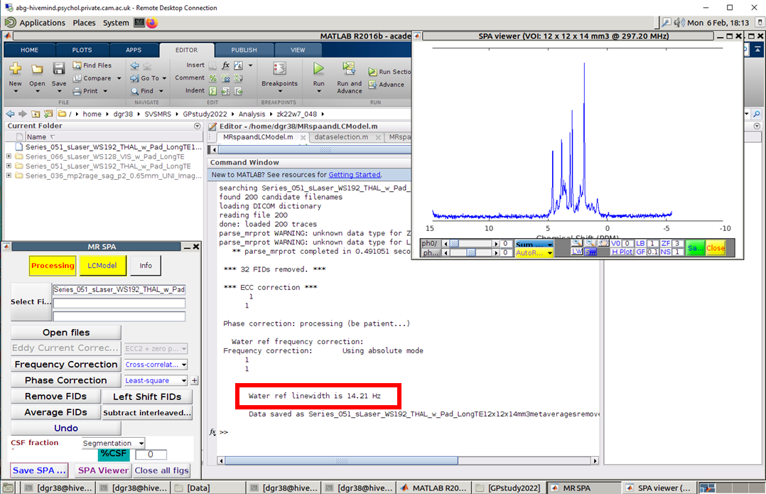After saving the SPA file the LW is displayed on the screen. This parameter cannot be retrieved afterwards unless it is saved. One can either take a screen grab (recommended) or write it down in study notes.

It is recommended to save the screengrab of this LW (including the dataset name) and save it in a ppt corresponding to the study.

1. For analysis add to your path the following:

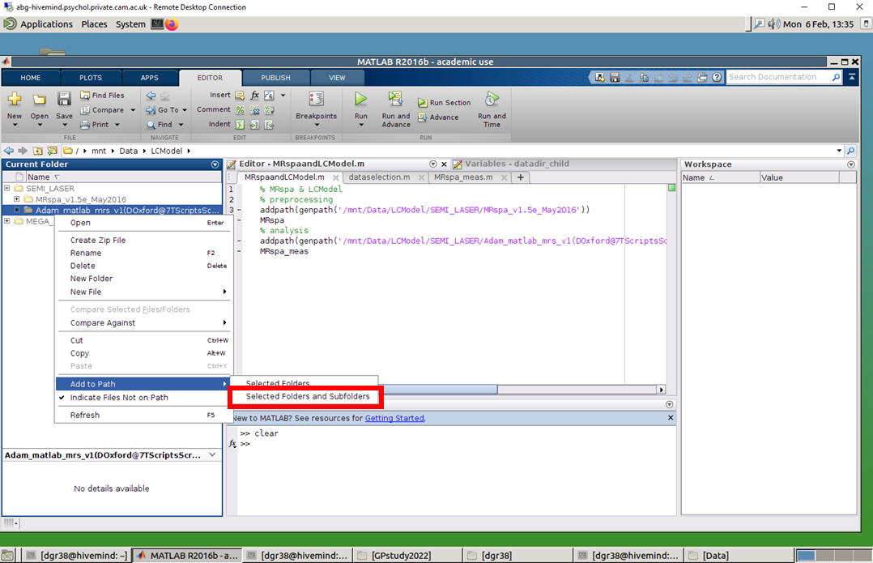/data/fox_cloud/share/app/imaging/SEMI_LASER/Adam_matlab_mrs_v1(DOxford@7TScriptsScripts_from_JalapenoLC_toolboxesAdam_matlab_mrs)’ either manually, or using ‘addpath’ (with subfolders).

1. 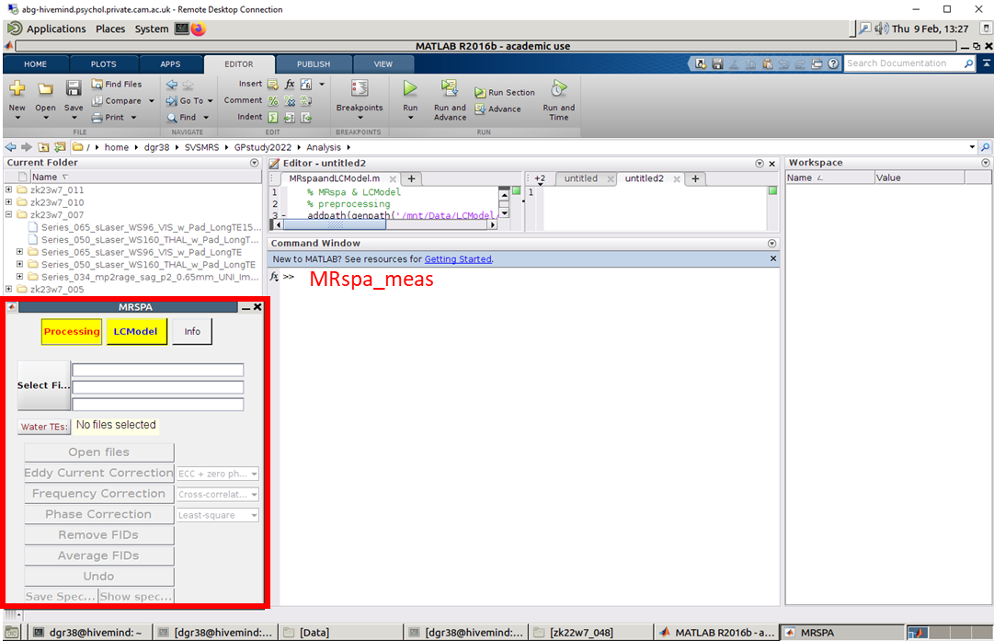Type in Matlab command window ‘MRspa_meas’.
2. 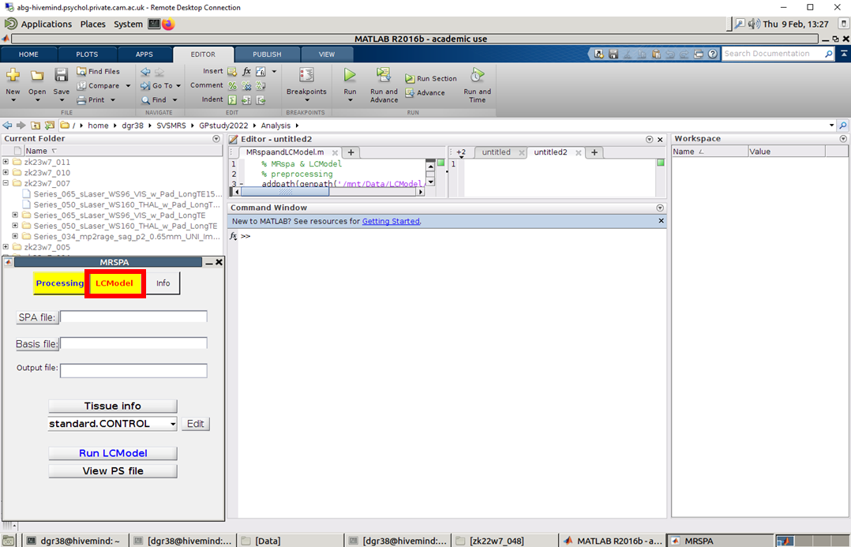Select the ‘LCModel option’.
3. Click on the ‘SPA file’ button and select the dataset to analyse.

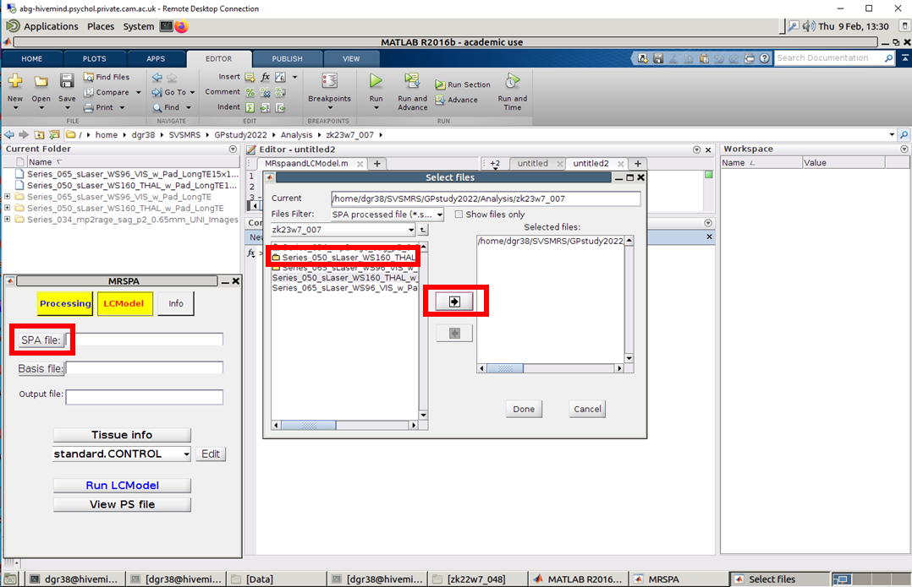Select the folder that contains your DICOM MRS data then click the arrow button and then the column ‘Selected files’ should update. Click ‘Done’ when finished.

After finishing, the ‘SPA file’ field is updated.

1. 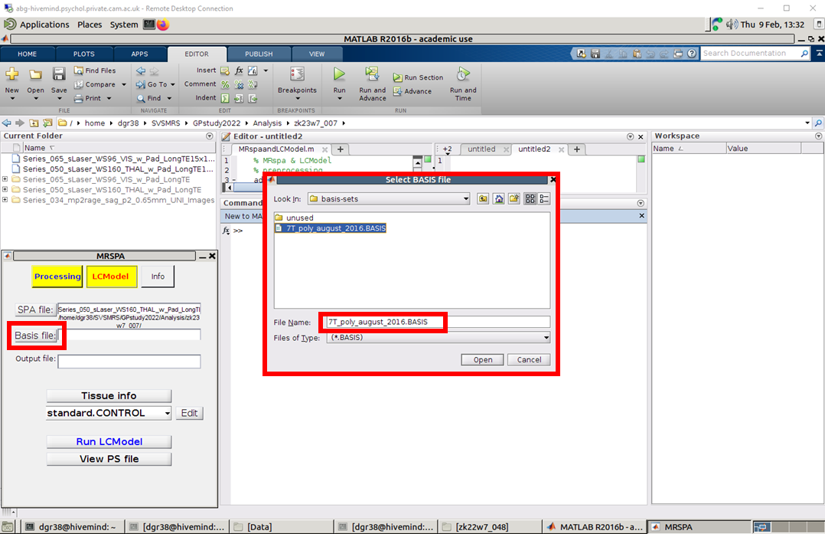Click on the ‘Basis file’ button and select the basis set to be used at analysis, usually ‘7T_poly_august_2016.BASIS’. Click ‘Open’; the field ‘Basis file’ will then update.

NOTE: if you can’t see this basis set file it means you did not add to the path the correct MRspa version for analysis. You probably retained the version used for preprocessing.

1. Click on the ‘Tissue info’ button. A new window pops up. All values should be filled in. If any is missing use the image below to find the correct value. Click ‘Save’ and this will store the relaxation correction values and will also fill in the field ‘Output file’ in the original interface.

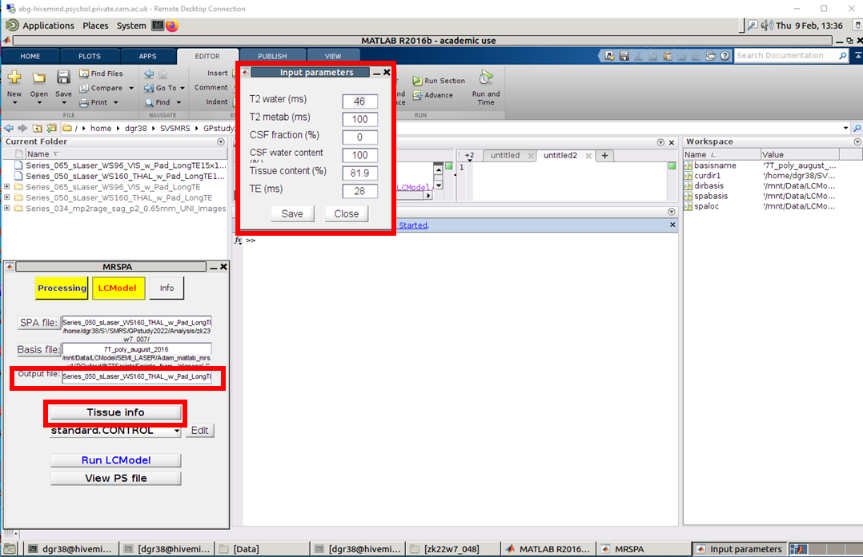

1. 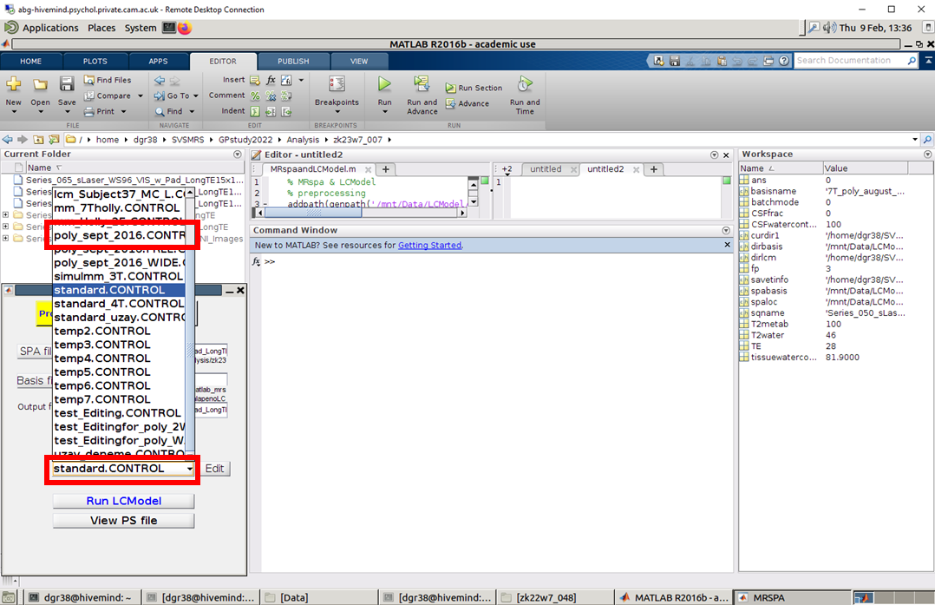Click on the ‘standard.CONTROL’ drop down menu and select the control parameters file ‘poly_sept_2016.CONTROL’

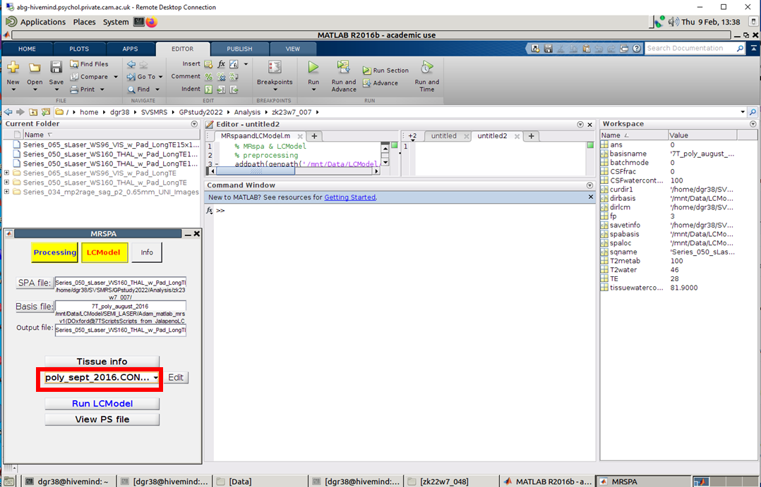

1. Click on the ‘Run LCModel’ button.

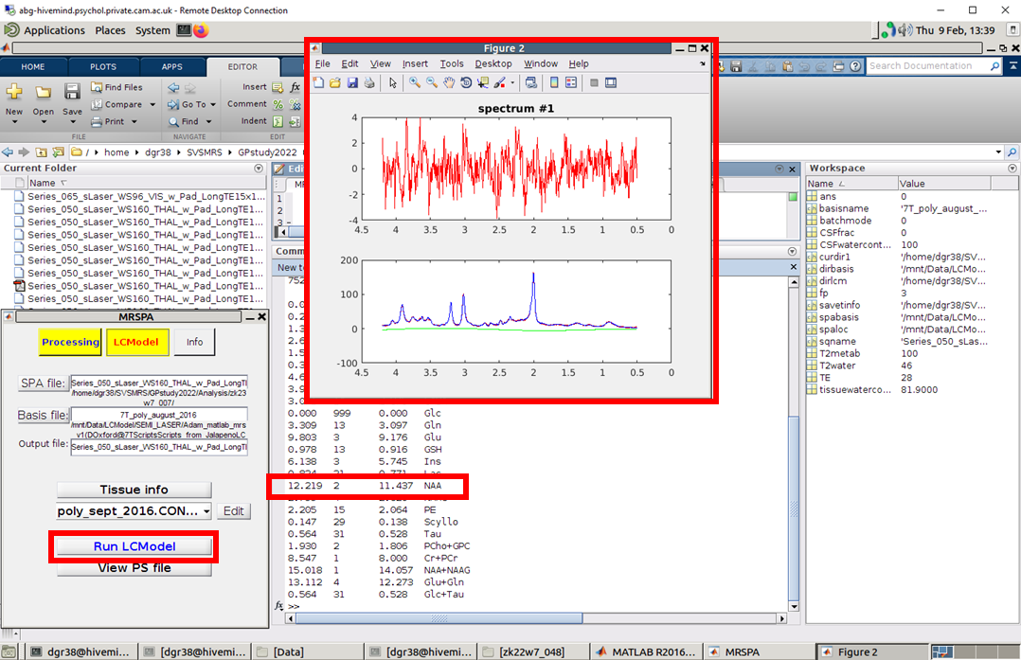

The output is a figure that contains: at the bottom, the processed data (red) and the simulated fit (blue), the baseline (green) and at the top, the residuals or the difference between the data and the fit. In the command window there will also be shown the metabolite info (left to right): so called absolute concentration (given in millimolar mM or institutional units i.u.), standard deviation or Cramer Rao lower bounds (CRLB) – a measure of the reliability of the metabolite fit, tCr ratio (NOTE: it is scdaled by a factor of 8 since tCr/tCr is 8; tCr = Cr+PCr) and metabolite name.

The output also includes other files, but most important is the pdf that has the LCModel output spectrum and individual fits, as well as other info such as the control parameters.

Other files are the CONTROL one that has the control parameters, the text files, the raw data, etc.

LCModel: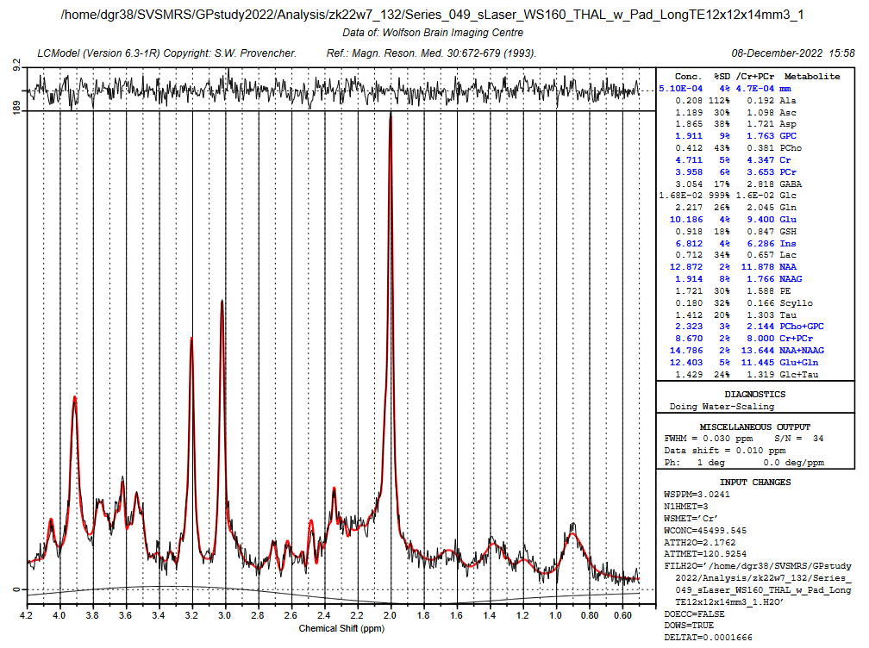

After pre-processing: you can follow the general pipeline. The only difference would be the Free Surfer segmentation part: For 7T data please do the following:

* 1. Set FreeSurfer environment (for most PC is already set – if you don’t know how to do it ask IT):
     1. Export FREESURFER_HOME=/home/fsl/freesurfer
     2. Source $FREESURFER_HOME/SetUpFreeSurfer.s
     3. Export SUBJECT_DIR=/home/fsl/_Your_Folder_Name_
  2. Now run cd ..-all to obtain surfaces and segmentations / masks
     1. recon-all –all –s OUTPUTFOLDERNAME –hires –I INPUTFILE.nii –expert expert.opt (change the input and output names as well as the expert.opt)
     2. Note that this step can take up to 20 hours for one file

The expert.opt file can be obtained by running the following from the terminal:

echo mris_inflate -n 50 > expert.opt

echo mris_inflate –n 100 > expert_hires.opt (for high resolution < 0.75)

If you’re getting an error, there might be issues with copying this text, make sure there is no extra spaces, and all the special characters copied right (e.g., the dash)

* 1. Check results in freeview
     1. Cd into the subject folder and on the terminal run freeview --v OUTPUTFOLDERNAME/mri/T1.mgz (or brainmask.mgz / wm.mgz)
  2. Convert results for BV from the terminal
     1. mri_label2vol --seg ribbon.mgz --temp rawavg.mgz --o ribbon-in-rawavg.mgz --regheader ribbon.mgz
     2. mri_convert ribbon-in-rawavg.mgz ribbon-in-rawavg.nii
     3. mri_convert rawavg.mgz rawavg.nii

Note that the mri_label2vol and mri_convert commands still need to be run once the recon-all step is finished.

# Appendix 3-Install LCmodel

Here is the method to install the LCmodel to the server.

If you met the met below, you may need to install the LCmodel to the server again.

1.Transform ‘lcm-64’ folder through FileZilla to the server.

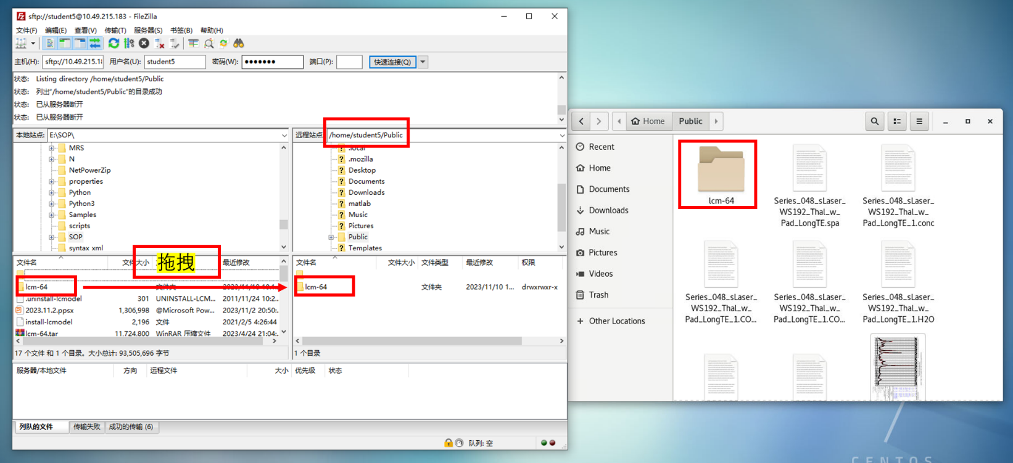

2.Right-click mouse->’Open in terminal’ ->Type ‘bash install-lcmodel’.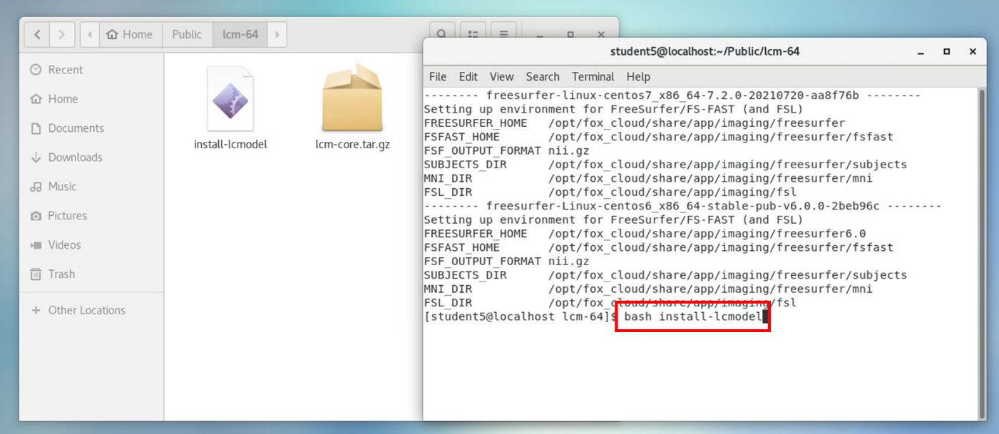

# Appendix 4-Training Data

The training data can be found in:

/data/fox_cloud/share/public/SOP/MRS/TrainingData

After processing TrainingData in step of Appendix 2, we will obtain LC-Model copyright, you can find it in the path where you save the ‘SPA file’, Copy it to your own window and open it through PhotoShop.

If you are not sure whether your operations are right, refer to the copyright below, you may pay attention to parameters like ‘GABA’, ’Glu’, ‘FWHM’ and ‘S/N’.

Please note that you don’t the authority to save files in the Public, and there may be some errors if you don’t

